Plan and Design
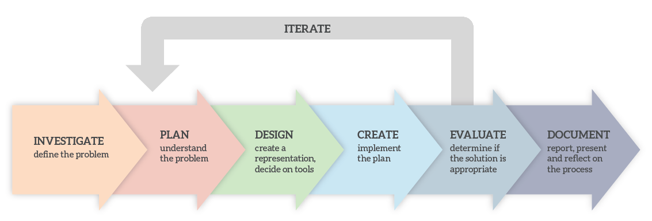

My project follows the Leaving Cert Computer Science Software Development Cycle, incorporating both waterfall and algae approaches. It uses a waterfall approach because the requirements and marking scheme remain the same throughout the project development cycle, and it’s also adopted an agile approach as I frequently reiterate back to previous stages to change my investigation ideas or fix any coding bugs I made during the create stage.

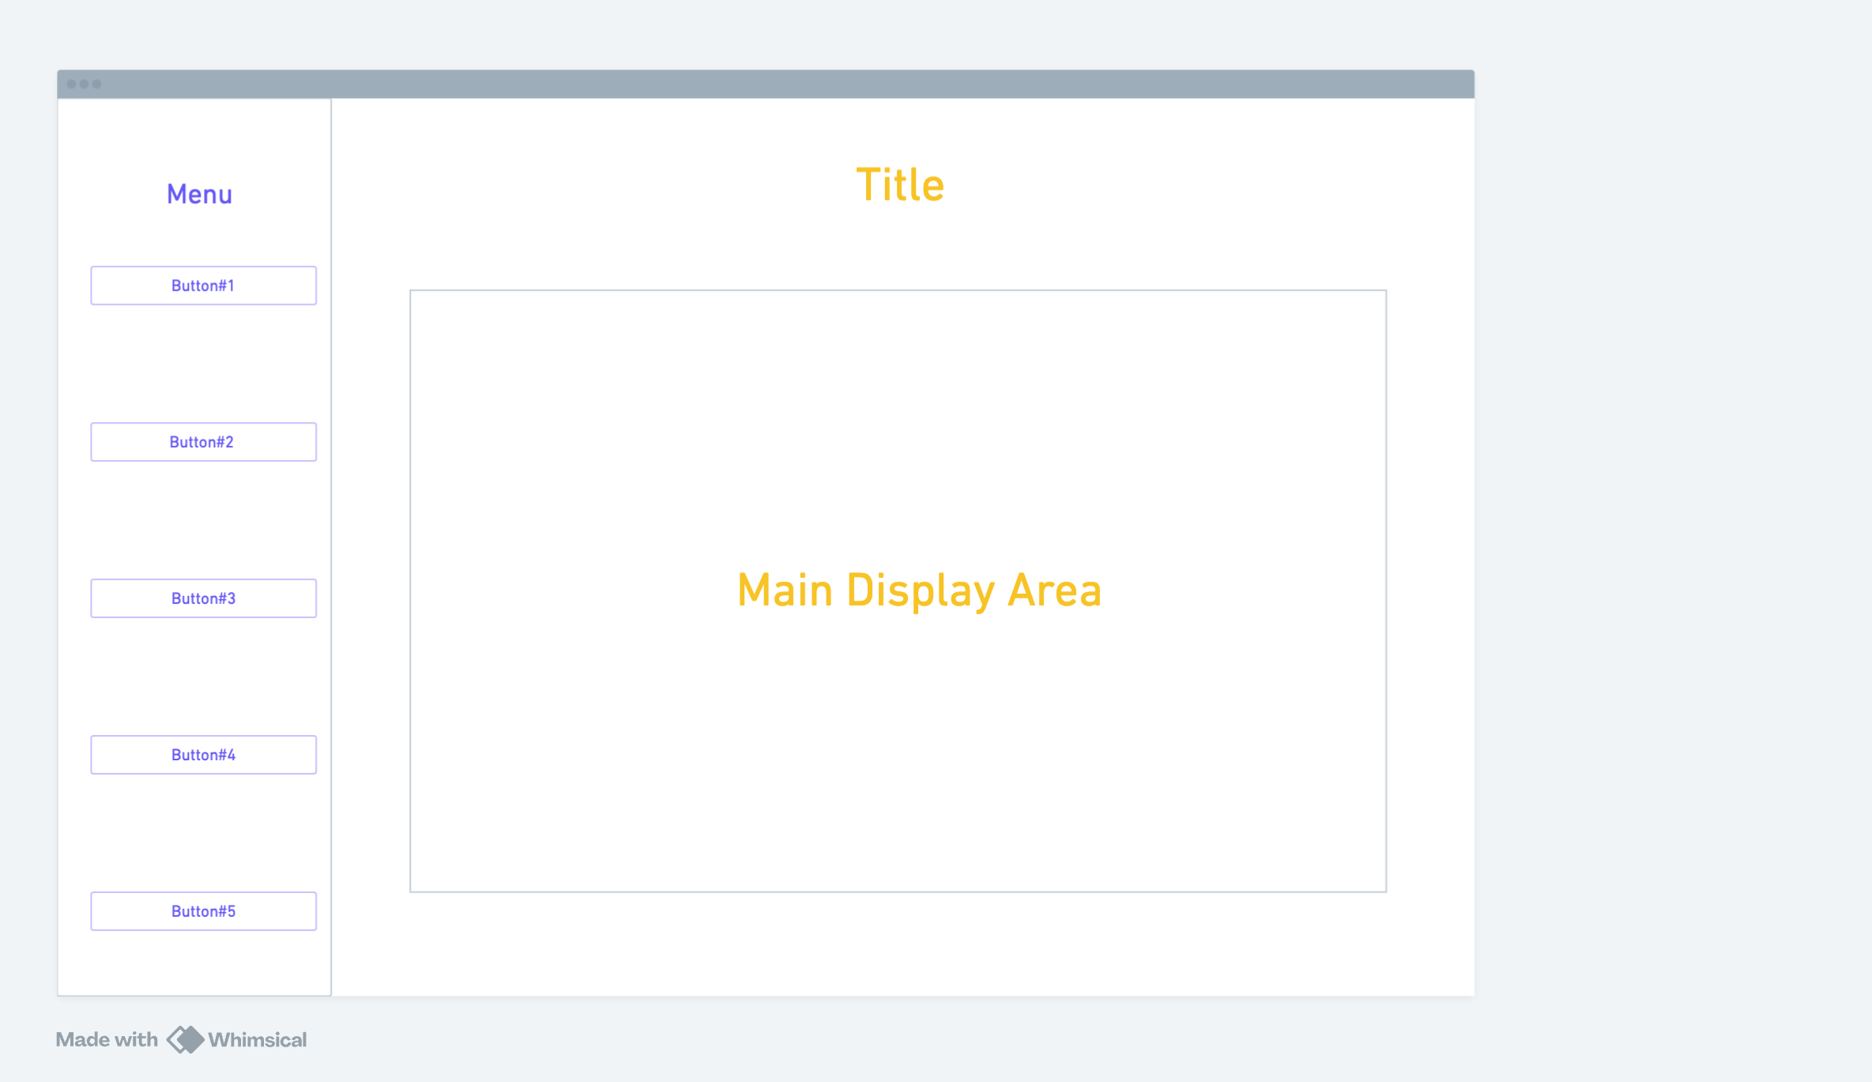

Artefact System Flowcharts

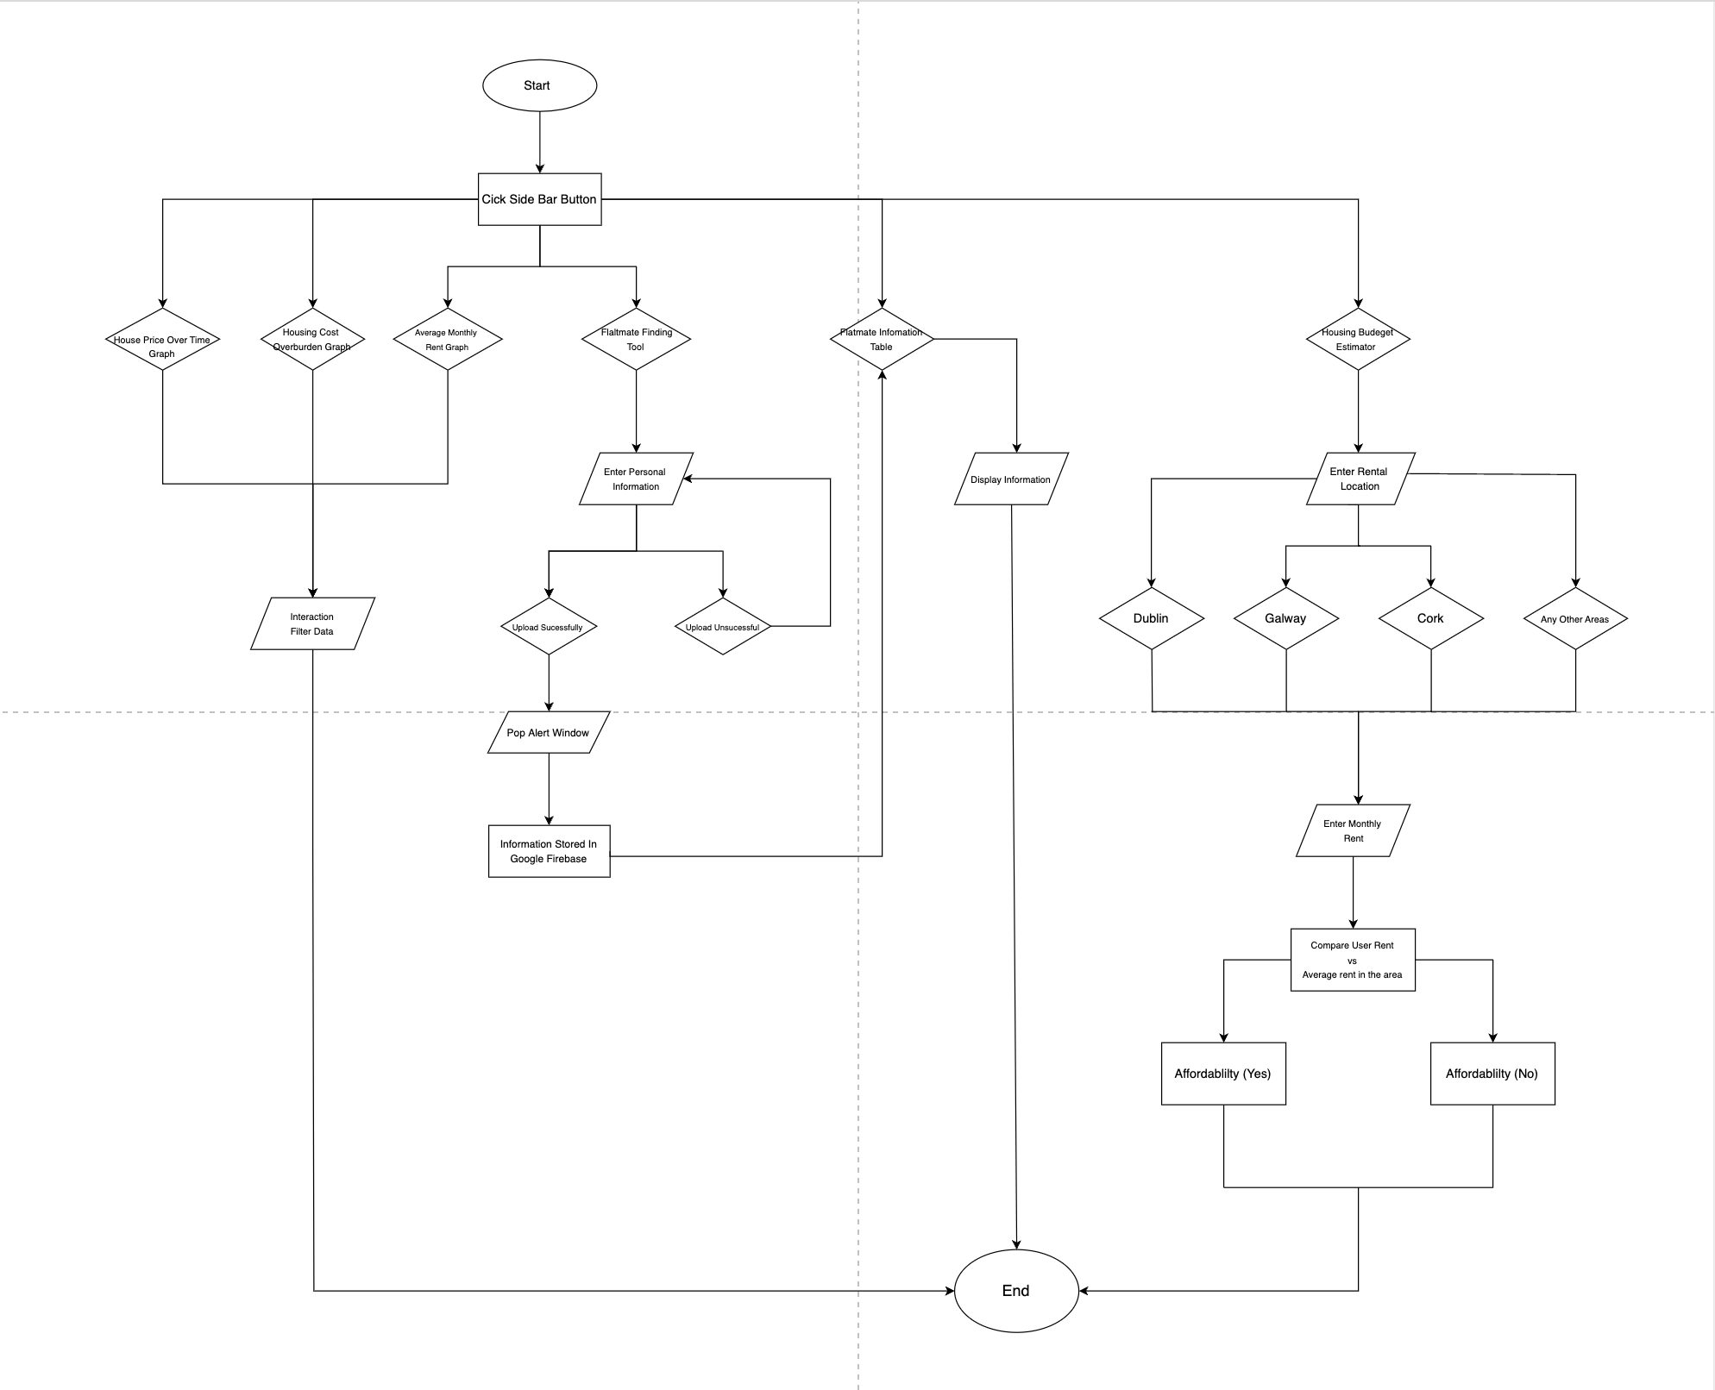

Python Extracting Sorting Flowchart

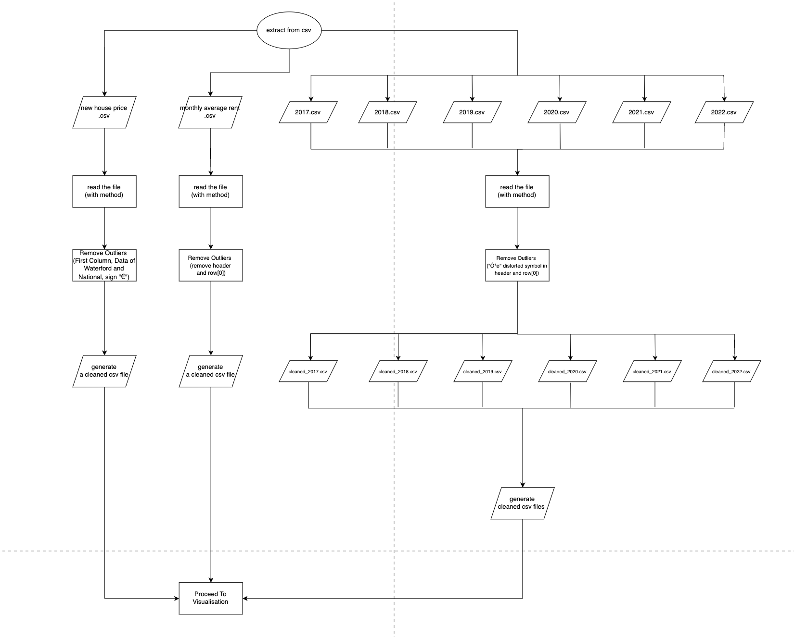

Python Visualization Flowchart

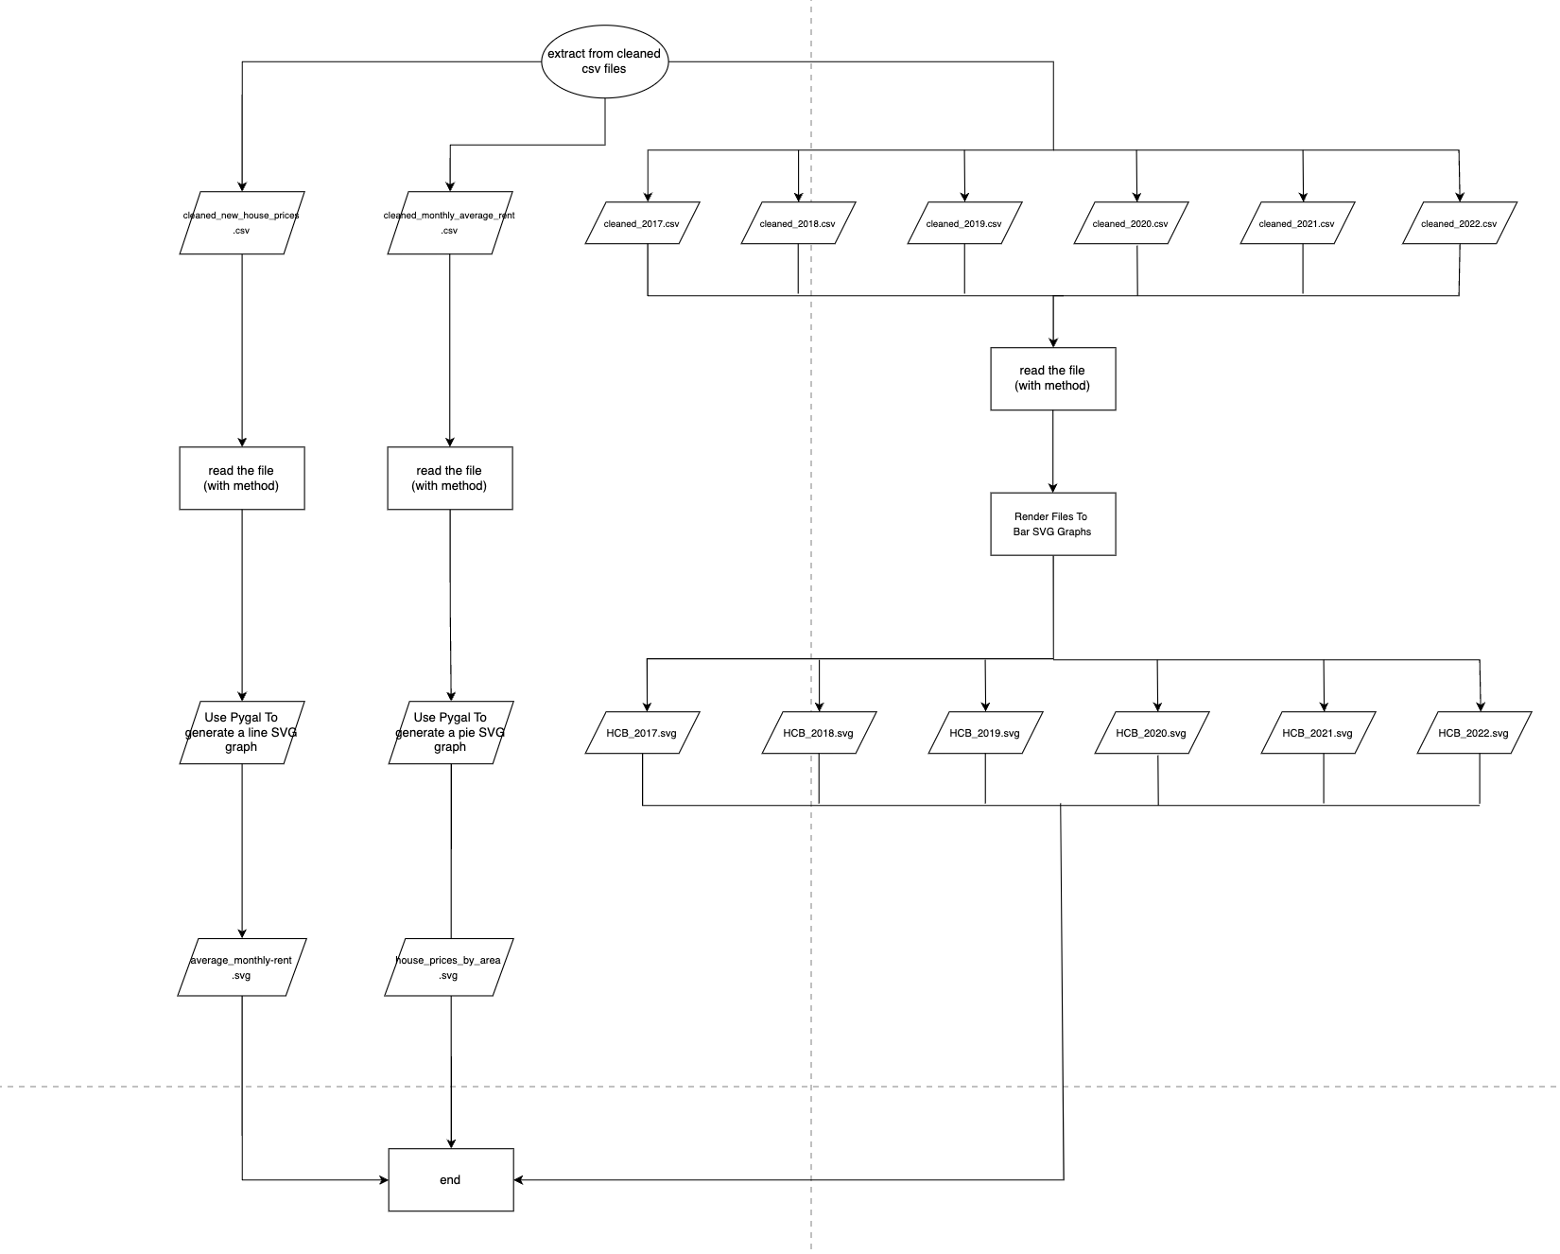

Basic requirements

1. Collect and prepare data

- I will download the data needed for my project from different publicly available datasets, such as Central Statistics Office.
- There will be elements I don’t want or distorted information in the raw data downloaded, So I will clean the data into suitable formats using Python on Thonny IDE. Additionally, I will merge and separate 7 years of data into a single CSV file for further processing.

2. Data analytics and Visualization

a. I will download the Pygal module to the Local Python3, for different data sets visualization. Three SVG graphs will be generated (Bar, Line, Pie)
b. Each graph will be clearly labeled with titles, axis labels, and legends.
Example title: House price over time by area
c. Both lists and dictionaries will be used as data structures during data analysis.

3. Basic Interactive Information System Interface
a. The web-based interface called “Housing Data Hub” will consist of three different interactive SVG graphs, a housing recommendation tool, and a form that will allows users to enter their personal information and budget to find flatmates.
b. Three Pygal Graphs will provide visualization to users, and graphs will be easily switched by clicking buttons on the side menu.

Advanced Requirements

1. Pygal graphs are fully interactive, allowing user to hover for details and filtering specific data.

2. A form will be created to allow users to enter their personal information and budget to find flatmates.
a. The data collected will consist of three data types: Name(str) Budget(float) Birthday (date)
b. The user information will be stored in Google firebase
c. Submitted data will be displayed on a separate page in table form.
In this way, users will be able to contact flatmates who suit their location and budget.

3. A rent affordability tool will be on a separate web page. It compares the user budget to the average monthly rent in the location and return a simple yes or no answer.

